Volunteers Needed
Come help organize the SVSBA music library
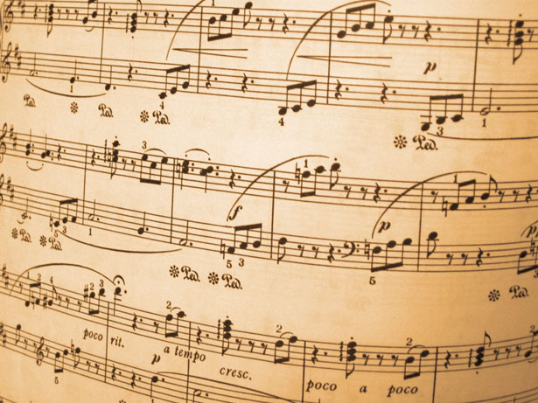
Call Mary & George Preston to arrange a time to help.
Phone: 650 – 483 - 6911
The only day that is not available is Saturday
Sun - Friday
Hours: 9 am – 9 pm (Except not Wednesday evening)
The library is located at:
471 Maidu Dr.
Auburn, California
Downstairs

